Submission to the ​Inquiry into the future of inter-regional passenger rail in New Zealand

Low Carbon Kāpiti

Who are we:

Low Carbon Kāpiti (LCK) is a grassroots community organisation made up of local people who want to see more action to reduce the causes of the climate crisis. Established in 2017, we have a current membership of 314, based across the Kāpiti Coast District. Our focus is both national and regional.

We wish to speak to our submission.

TOR#1

Investigating possibilities and viability of passenger rail in underserved communities, those with prior rail links that have been disestablished, and those currently advocating for improved rail links.

There are many communities, including within Kāpiti, currently not well served by long distance passenger rail. Yet many of New Zealand’s towns and cities were constructed along rail tracks. In 1881, the privately owned Wellington & Manawatū Railway Company opened between Wellington and Longburn. The Wellington & Manawatū Railway Company was nationalised in 1908 and the line through Kāpiti and Horowhenua became the lower North Island section of the North Island Main Trunk Line to Auckland.
Gradually an electric suburban rail network has been extended up the coast, first to Paekākāriki, then Paraparaumu and most recently to Waikanae. But electrification, and double tracking, has yet to reach Kāpiti’s most northern town Otaki.

Once it was possible to travel from Kāpiti by train to many areas on the North Island. Once it was possible to reach Auckland, and all stops along the main trunk line, by daily night and day trains. New Plymouth, and towns along the way, could be reached by train. Similarly, trains went all the way to Gisborne. Now, but only from September, it is only possible to travel to Auckland once every couple of days. At a very high price, especially when compared with air travel. And is no longer possible to get off at Taumarunui, if you want to ski or holiday at the lake.

When the aging and increasingly unreliable Capital Connection is running, it only passes through Kāpiti in the early morning and back in the evening. It runs separately from the Metlink service, so is not part of Metlink’s timetabling or alert systems.
Kāpiti airport is likely to close in the near future. In a low transport emission transport system, Kāpiti residents should be able to reach all major towns and cities to the north by train.

TOR #2
Gaining insights into the viability of passenger rail sitting alongside KiwiRail’s freight network.

Freight and passenger rail should not be a binary decision. It is not a choice between one or the other. Getting freight off trucks and on to trains helps improve road safety, reduce emissions, reduce road repair bills and reduce traffic on our roads. Passenger rail achieves exactly the same goals.

In some parts of the country, there would need to be infrastructure upgrades to allow passenger services to sit alongside freight services.

TOR #3
Evaluating existing inter-regional passenger rail, such as the Capital Connection, and how these services work between local and regional councils and central government.

The Capital Connection is an example of the long term under-investment in our regional rail network. Old rolling stock frequently breaks down leading to bus replacement services, or no replacements for some stops. New trains and better frequency would positively impact use of the service. The Greater Wellington Regional Council, with support from Horizons Regional Council developed a strong business case that proposed upgrades to rolling stock, station facilities, and track infrastructure which would increase service reliability and frequency for passengers in Kāpiti, Horowhenua, Manawatu, and Wairarapa. Disappointingly, the request for new hybrid diesel electric trains was not included in the 2022 Budget.

New Zealand’s legislation, regulations, policies, and structure of government agencies all present barriers to the development of inter-regional rail services. Regional Councils are responsible for public transport, but as soon as a service crosses a regional boundary, funding and organisational issues occur. While this clearly impacts the development and maintenance of long distance and inter-regional transport, it also impacts people that live in the often-neglected borderlands, like Pōkeno and Ōtaki.

New inter-regional rail services need the support of both local government, central government, and an operator committed to supporting long distance passenger rail.

Central government could play a greater role in coordinating inter-regional rail services. Ultimately, these services are about national connections, and it makes good sense for the central government to play an active role in coordinating and balancing priorities.

The New Zealand Rail Plan set priorities for government investment. The current rail plan focuses on urban commuter services and scenic tourist-focused rail and ignores inter-regional passenger rail entirely. This is an obvious big gap, given the cost of fuel and the increasing threat of climate change, and the rail plan should be revised to include inter-regional passenger rail.

TOR #4
Gaining insights into the integration of regional rail into existing local public transport networks.

Passenger rail needs to be part of an integrated public and active transport system that connects trains, local buses, cyclists, pedestrians, long distance coaches, and on-demand transport. This means looking at things like:
  - Transport connections
  - Frequency and timetables
  - Station facilities
  - Ticketing
  - Use of technology

Cyclists and rail go together. Trains provide an excellent opportunity for cyclists to bike to their local station and put their bike on the train to travel long distances. Passenger trains should be able to take cyclists to many of New Zealand’s cycle trails, especially those in the central North Island. As snow retreats from Ruapehu due to climate change, the area is focussing more on attracting people to cycle its trails.

Another issue is accessibility. For example, passengers using wheelchairs should be able to seamlessly connect between rail and bus services.

TOR #5
Investigating the climate and emissions reductions possibilities of passenger rail, and how this links to VKT (vehicle kilometres travelled) reduction targets in the Emissions Reduction Plan, and including electrification between regions.

There are plans to reduce driving within our largest cities. But there are no well-developed plans to reduce driving between regions. In fact, the continuing building of motorways supports more driving through induced demand.
We are also major flyers in New Zealand. On a per capita basis, New Zealanders emit seven times that of people living in the UK and nine times that of Germany. Part of the reason for the difference is their extensive rail networks and our lack of them.
In Auckland’s recently adopted Transport Emissions Reductions Pathway, there is a target of reducing domestic aviation emissions by 50% in just eight years through to 2030.
There are a range of possibilities for reducing aviation emissions. These include travelling less, and using other forms of communication more, such as Zoom meetings; relying on aviation decarbonisation through the use of Sustainable Aviation Fuels and bringing electric planes; and switching to rail.
Travelling less can be done immediately. But switching to rail is both a very attractive short and long term option. Academics and business people need to be encouraged to fly less and Zoom more.
Rail transport is a very energy efficient form of transport with excellent green credentials. Steel-wheels upon steel-rails provides low friction and therefore low rolling resistance, resulting in much reduced energy usage compared to air and road transport. While our narrow gauge railway and challenging terrain make it more difficult to run high speed, tilting trains and other technological advances can overcome some of the disadvantages.

Table 1 shows estimates of per person emissions for various modes of travel between Auckland and Wellington by plane, car and train.
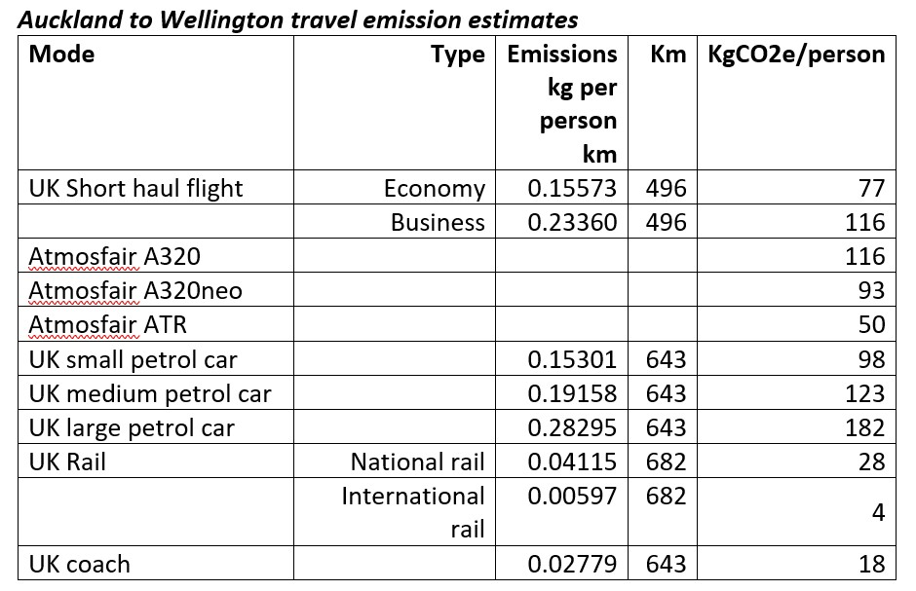
The UK estimates are sourced from official government data https://www.gov.uk/government/publications/greenhouse-gas-reporting-conversion-factors-2019. Atmosfair is a carbon calculator

The estimates for fully electrified rail, based around the Eurostar service, is for the trip between Auckland and Wellington to emit just 4kg per person. Flying on the lowest emission alternative, a turboprop ATR, has emissions over 12 times higher. Or, to put it another way, if we compare with the planes that do actually fly this route, the Airbus A320 neo, a person catching n fully electrified train service would have a 96% reduction in emissions.
As shown, rail transport becomes a very low emissions way to move people and freight when electrified. Modern electric locomotives and passenger rolling stock can recoup energy via regenerative braking technology, recapturing between 10-45% of the original energy used. This recouped energy can be used by other trains or feed back into the national power grid.

Further electrification of our railway network means inter-regional trains could have an even bigger impact on carbon emissions.

Decarbonising aviation is a challenging task and will not happen any time soon. But even if sustainable aviation fuels can be produced, or electric planes come into service for some short hops, they will involve a significant and ongoing use of valuable renewable energy. While there are clearly large capital investments needed to revive passenger rail, the on-going energy requirements to run them are extremely low.

Kāpiti promotes green nature-based tourism. It is not a major destination for international tourists. Instead, many visitors come from the north including Hamilton and Auckland. A night train would be ideal to support such tourism. An Auckland based visitor would set off, perhaps bringing their bike, in the evening and arrive for breakfast in Kāpiti, ready for a day of adventure on our essentially flat cycleways.

TOR #6
Investigating potential rail expansions and investments in specific areas, such as Tauranga (following a recent report on the re-introduction of passenger rail) and the Lower North Island (following a business case funded at Budget 2021).

Tauranga is part of the ‘Golden Triangle’, an area of considerable demographic and economic growth including Auckland and had a rail service as recently as 2001. The city has experienced remarkable population growth since that time and now boasts a population of nearly 160,000 people. Much of this growth has occurred in dormitory suburbs built alongside rail infrastructure, such as Ōmokoroa and Papamoa. A rail service between Auckland and Tauranga would also connect Tauranga with Hamilton and increase the frequency of services between Hamilton and Auckland. While a Tauranga rail service requires considerable investment in rolling stock, and track and station infrastructure, this is a worthwhile long term investment.

The Lower North Island has rail lines connecting Wellington with some of New Zealand’s largest towns and cities including: Gisborne, Napier, Hastings, New Plymouth, Whanganui, Palmerston North, Masterton, Feilding, Hawera, and Levin.

We also need fast, frequent and affordable Auckland – Wellington and Picton - Christchurch services
  - Night express trains in both islands
  - Daily services stopping at smaller communities
  - Canterbury and Dunedin regional commuter rail services
  - A Bay of Islands to Rotorua service connecting major tourist centres
  - Other new regional services
  - Building of new tracks to connect unserved areas

